ISSACK WAITHAKA
cs-sa07-24085

Introduction
- Network enables two computer to communicate with each other

Network Types
- WAN(Wide Area Network) is also referred as the internet

- LAN/WLAN – (Local Area Network and Wireless Local Area Network) → wlan is able yo transmit data without cables

- VPN
- Site to site → Used to join company networks together over the internet
- Remote Access VPN – involves creating a virtual interface that behaves as if it is on a client networks
- SSL VPN - a vpn that is done within a web browser

- Gan is known as the Global Area Network
- Man (Metropolitan Area Network) Connect several Lans
-Pan/wpan allow devices to be connected to form a network to enable data exchange

Networking Topologies
- This is an arrangement and physical or logical connection of devices in a networks
- Point to point topology is a connection between two hosts
- bus topology all hosts are connected via a transmission
- Star a network components that maintains a connection to all hosts.
- Ring each node is connected to two cable, one for incoming and the other for outgoing
- Tree an extend for star topology
- Hybrid combines two or more topologies
- Daisy chain, this is when a chain of connections is formed when hosts are connected using cables

Proxies
- A proxy is when a device or service sits in the middle of a connection and acts as a mediator
- Forward Proxy a client makes a request and the computer carries out the request
- Reverse Proxy - Filters incoming requests
- Transparent Proxy – Client does not know it exits
- Non-transparent we are informed of its existence

Networking Models
- The OSI model used to describe and define communication between systems
- it has seven layers

- The TCP/IP term for protocols responsible for switching and transport data on the internet

The OSI Model
7. Application Layer – controls input and output of data and provides the app functions
6. Presentation – transfer system-dependent presentation of data into a form independent of the app
5. Session – controls the logical connection between two systems
4. Transport – used for end-to-end control of the transferred data
3. Network – Data id transmitted over the entire network from the sender to receiver
2. Data Link – Enable reliable and error-free transmissions in the respective medium
1. Physical – Techniques for transmission

The TCP/IP
4. Application – Allow applications to access other layers’ services and define protocols
3. Transport – Provide TCP and UDP datagram
2. Internet – Responsible for host addressing, packaging and routing
1. Link – responsible for placing the TCP/IP packets on the networks medium

IP is manly used fo Logical addressing and Routing
TCP is mainly used for Error and control flow and application support

Network Layer
- Controls the data packets which are then transferred from node to node until they reach target
- Most used protocols on this layers are: Ipv4/ Ipv6, Ipsec,ICMP,IGMP,RIP,OSPF

IP Addresses
- Media Access Control is used to identify host in network
- IP is used to identify device on the internet and ensure delivery of data to the correct receiver
- IPv4 consists of 32-bits combined into 4 bytes ranging fro 0-255
- It is dived into host part which is assigned by the router and network part which is assigned by the network admin
- Divided into classes a-e

Subnetting
- Is the division of an address range of IPv4 addresses into smaller addresses

Questions
1.
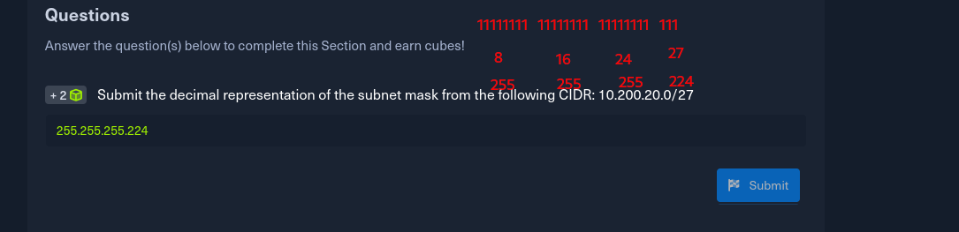
2.

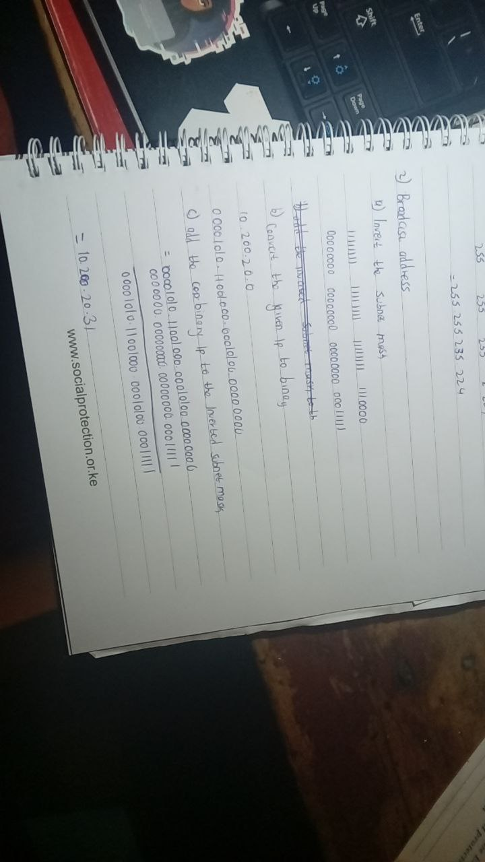
3.
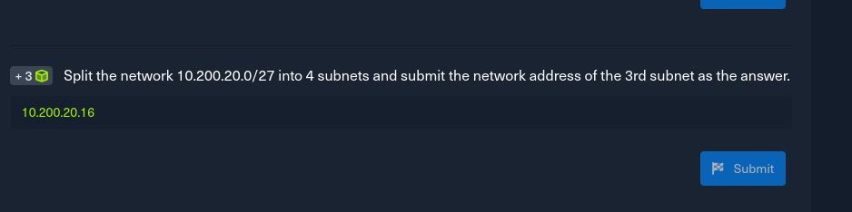

4.
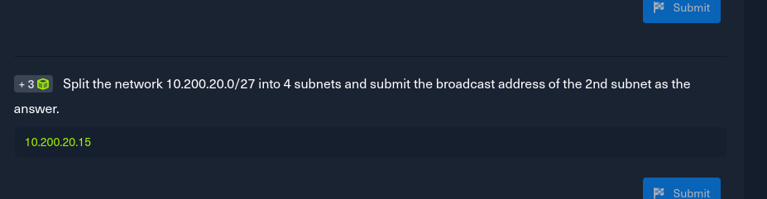

Mac addresses
- It is a physical address for network interface.
- The first half of a mac is called the organization unique identifier for the manufacturer
- The last half is called Individual Address part or Network Interface Controller assigned by the manufacturer
- Multitask is Identified when the last digit of the first octet is 1 and it sends the packets only once to all hosts
- Broadcast packets are transmitted simultaneously from one point to all member s of a network
- Arp request is sent when a device on a LAN wants to with another device on LAN

Ipv6 Addresses
- It is 128 bit long.
- Hexadecimal make the binary representation more readable

Wireless Networks
- These are computer networks that use wireless data connections between network nodes
- It use radio frequency RF to transmit data between devices
- WiFi has security features such as Encryption, Access control and firewall

Key Exchange Mechanisms
- This method allow parties to agree on a shared secret key over an insecure communication channel that encrypts the communication between them.
- The Diffie-Hellman allow two parties to share key without any prior communication or shares private information
- RSA – Uses properties of large prime numbers to generate a shared secret key

TCP/UDP Connections
- TCP ensures that all data sent from one computer to another is received and if error occur and message does not reach the receiver, the receiver send a message back for the sender to resend
- UDP, speed is more important that reliability. If message does not reach receiver no data will be sent back
- IP packet is data used by the network layer of the Open Systems Interconnection
-

Cryptography
- Symmetric uses same key to encrypt and decrypt the data
- Asymmetric method that uses two different keys. It uses public key to encrypt and private key to decrypt.

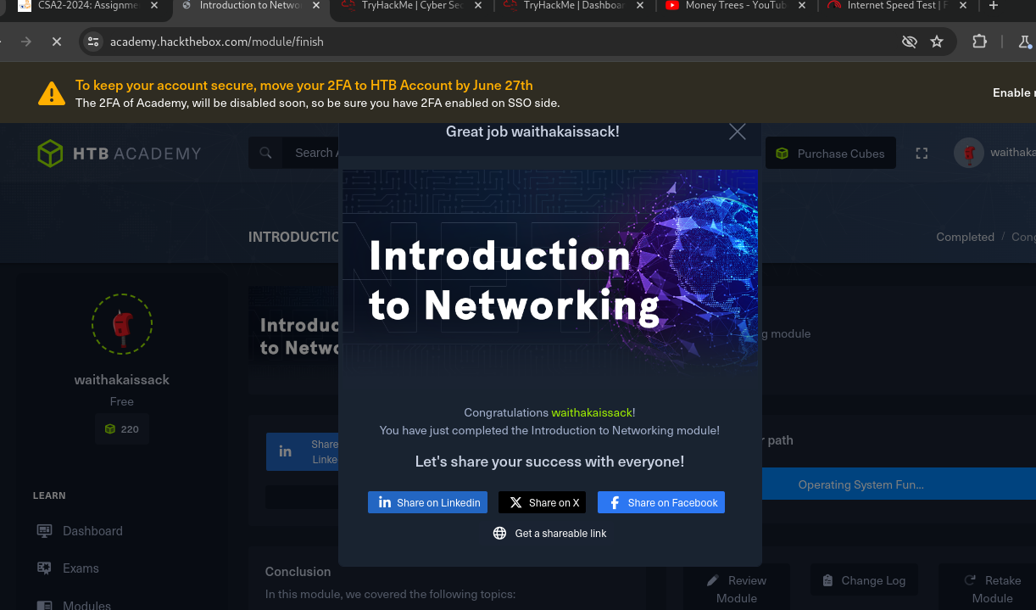

Conclusion
In this chapter I went deep into networking and it connection to cyber security. I have leant that networking plays a very crucial role in cyber security. You have to understand how network works in order to protect it.

